

**Documentation By:  
Syed Muhammad Hassam Uddin**

**Certificate Of Completion**

This is to certify that **Syed Muhammad Hassam Uddin, Aman, Abdul Latif, Saad, Fariyal and Fahad** have successfully completed their ACCP Semester E- Project.

Submitted to: **Aptech Computer Education**

On

**November 27th, 2023**

**ACKNOWLEDGEMENT**

First of all, we would like to thank Almighty Allah for giving us strength and ability to complete this project.

And then, we would like to express my special thanks of gratitude to our teacher Sir Noman and Sir Usman who guided us on the project Bright World which also helped us in doing a lot of new learning and we came to know about so many new things we are really thankful to him.

We are highly thankful to Sir Noman and Sir Usman for his guidance and constant supervision as well as for providing necessary information regarding the project & also for his support in completing the project.

Lastly, we would also like to thank our parents and friends who helped us a lot in finalizing this project within the limited time frame. We also express our sincere gratitude to E-Project team from Aptech Head Office, for their valuable guidance and support for the completion of this project. We earnestly hope that this project will provide all the necessary information required by the user to fulfill his/her inspiration. However, suggestion and Feedbacks for improvements will be thankfully welcomed & acknowledged.

PROJECT SYNOPSIS

BrightWorld is having store for LED Lights. They have collection of lights. Now with the changing environment, they want their presence on Internet. Hence they need to have a website with all their products listed on the website. Consumers should find it easy to view various products and decide upon purchasing the right product to meet their requirements. A website needs to be designed to display various lights available with the store.

CUSTOMER REQUIREMENT AND SPECIFICATION

The Web site is to be created based on the following requirements.

1) The Home Page should be created making use of Sections with a suitable logo, the header section can be added which will show images of various LED Lights.

2) The site must contain the links to navigate through various types of LED Lights.

3) Links of LED Lights can be categorized like (Bulbs, Spot Lights, Decoration Lights, Smart Lights etc.)

4) Specification and Pricing of Lights should be added along with the images.

5) Website should provide section for various brands offered in the store.

6) Gallery section should be added for viewing different images.

7) Feedback must be allowed to enter by the viewer

8) Gallery, About us, Contact us link must be added.

9) The complete description must be allowed to get download as pdf or doc file.

10) The advertise section with various facilities provided should be mentioned.

**HARDWARE AND SOFTWARE REQURIEMENTS:**

Hardware

• A minimum computer system that will help you access all the tools in the courses is a Pentium 166 or better

• 64 Megabytes of RAM or better

Software

• Notepad/HTML editor/CoffeeCup

• Angular / Angular JS / React / BootStrap

• Dreamweaver / Figma

• MS IE / Chrome / FireFox / Netscape /MS Edge

USER GUIDE

Home

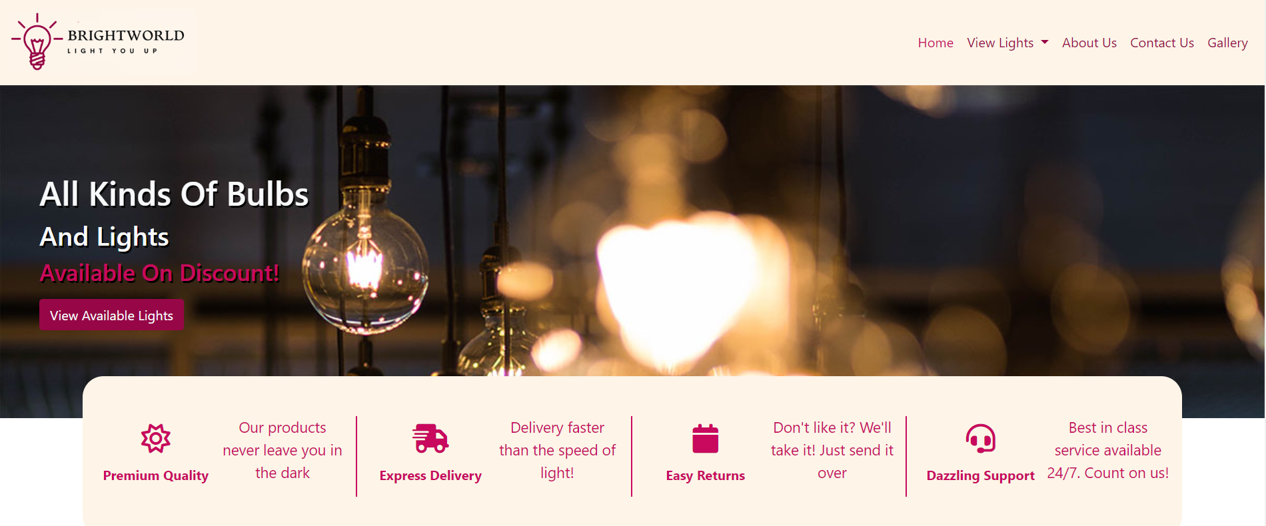

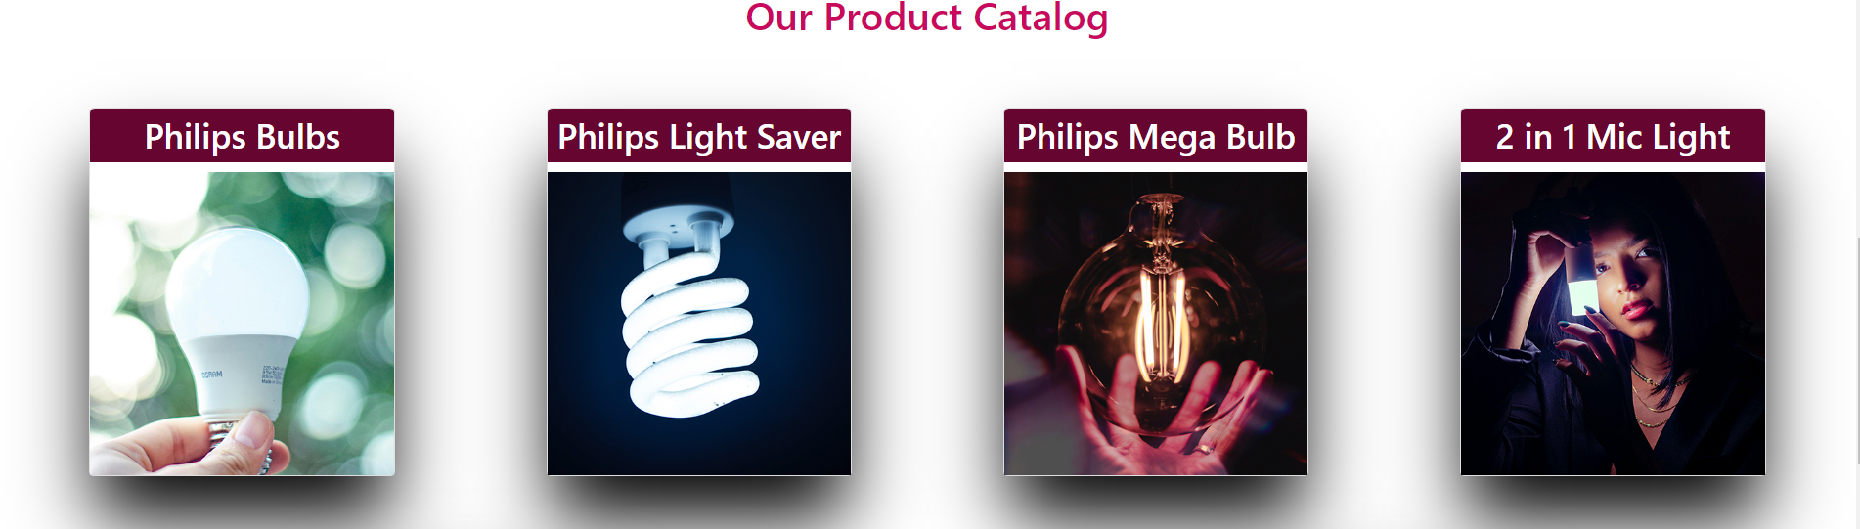

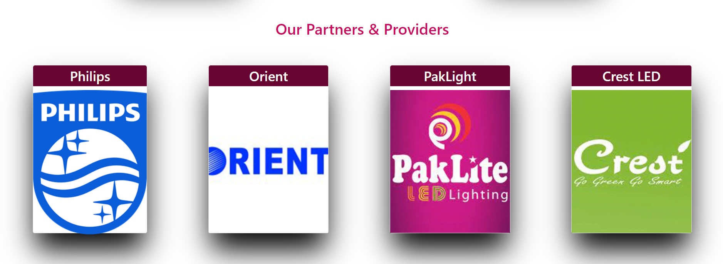

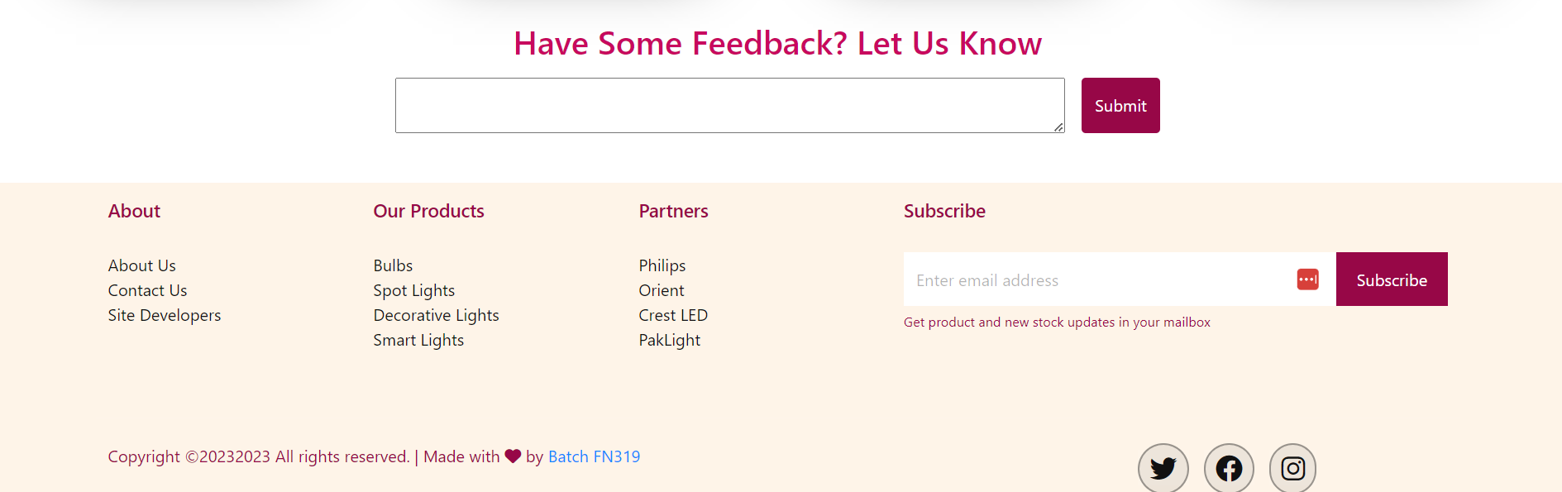

Product Page:

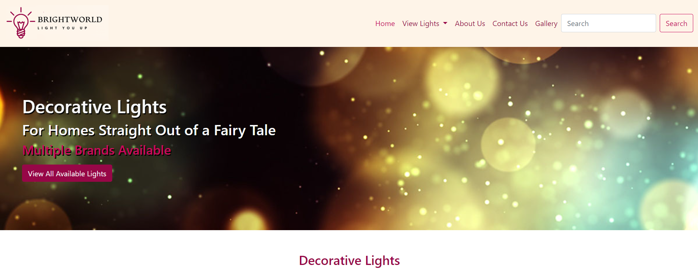

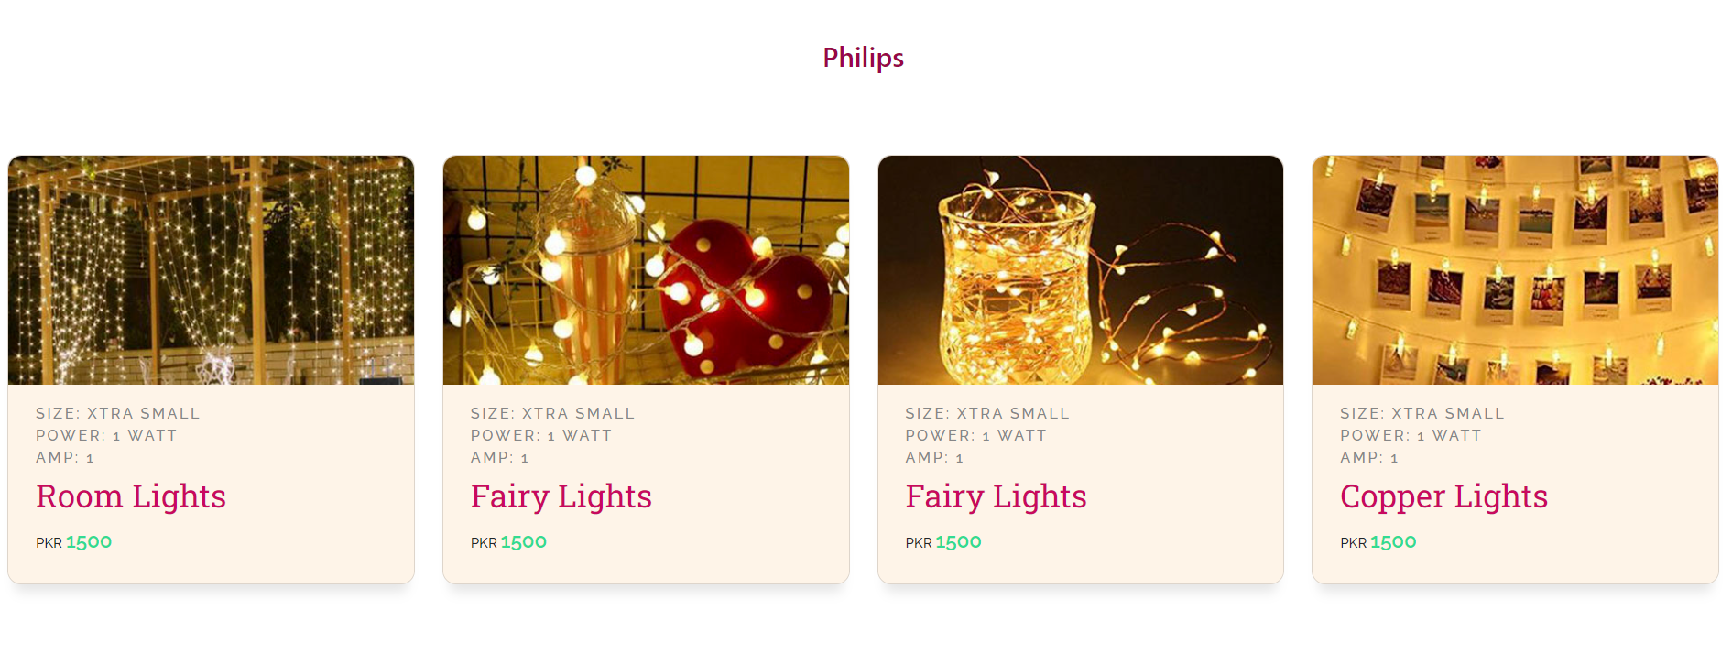

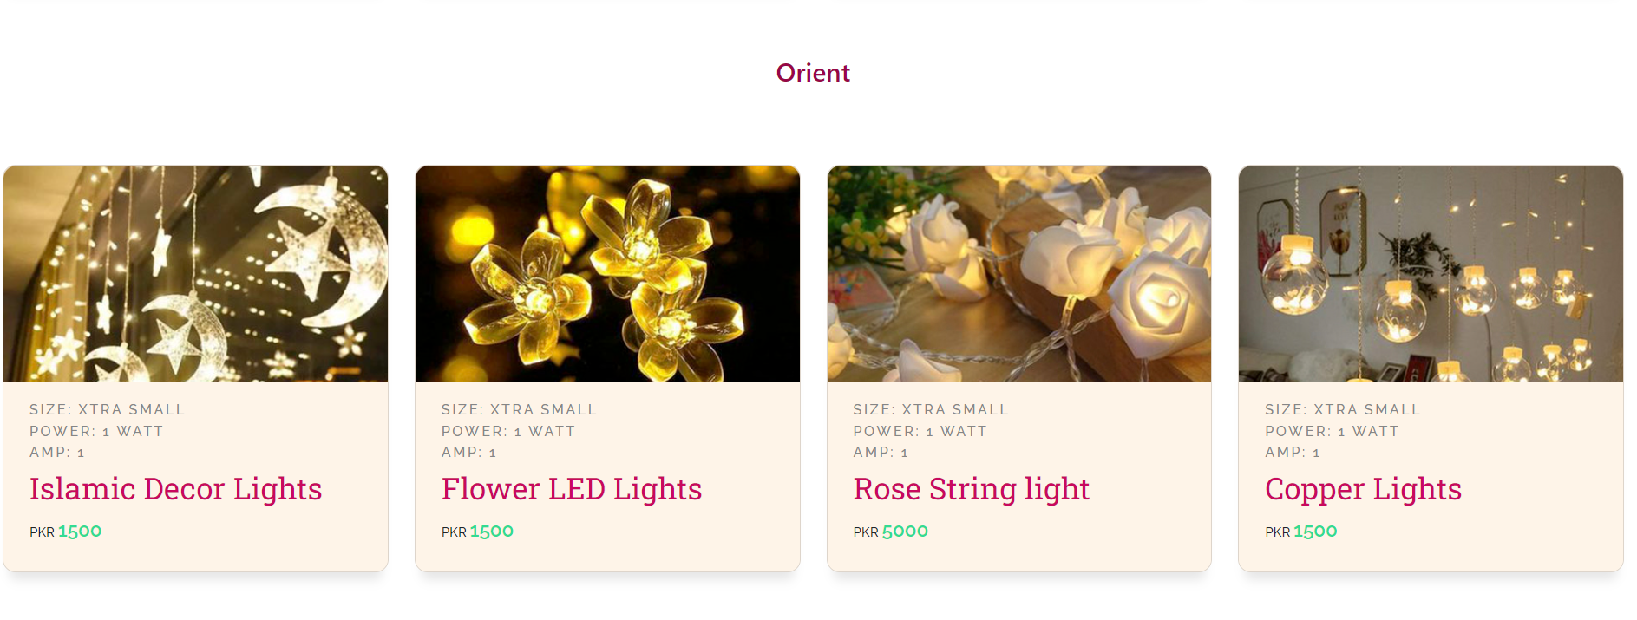

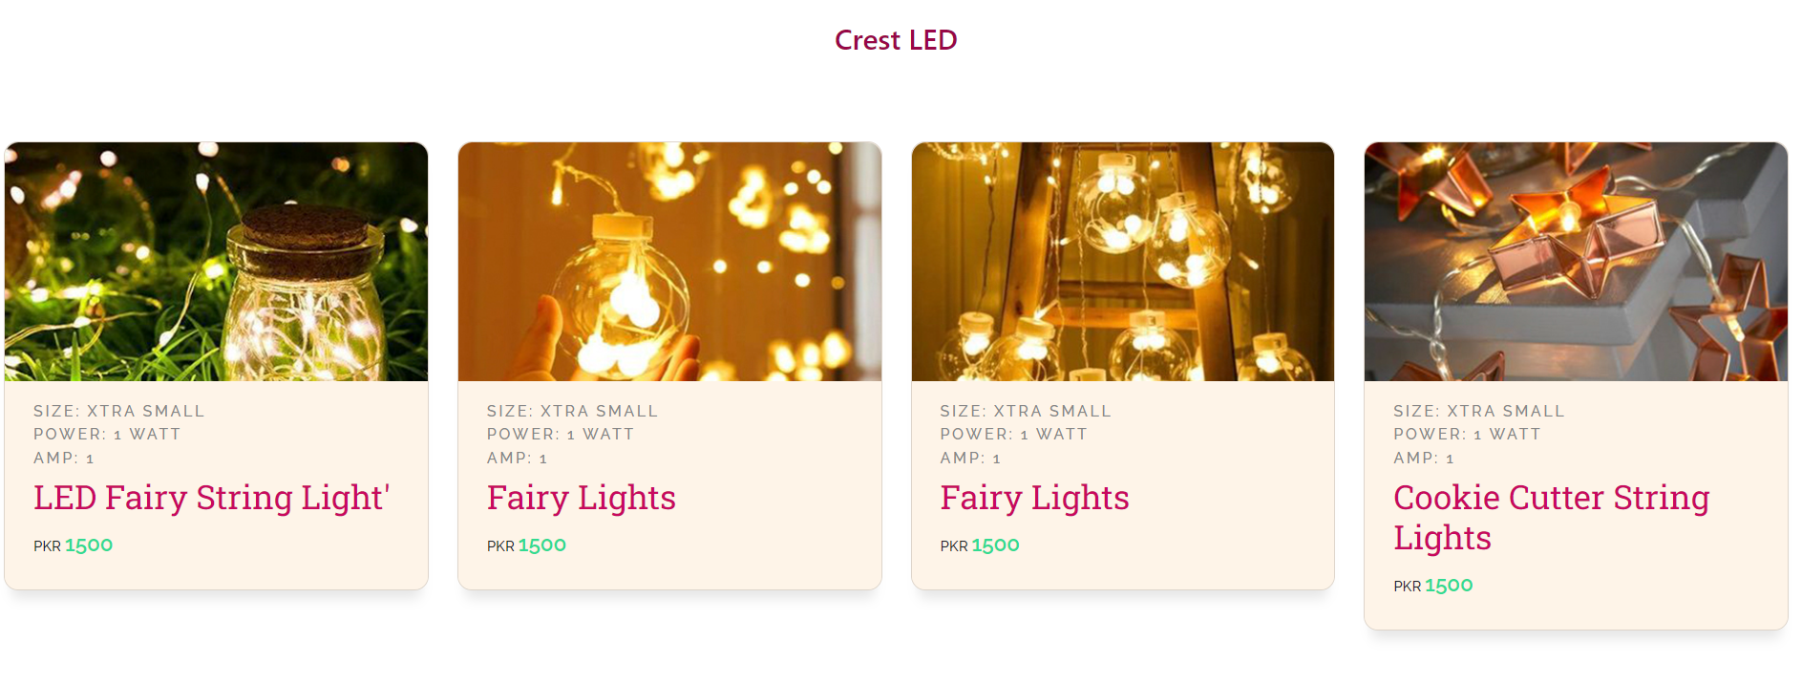

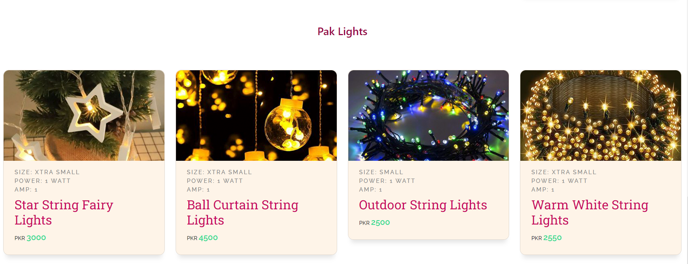

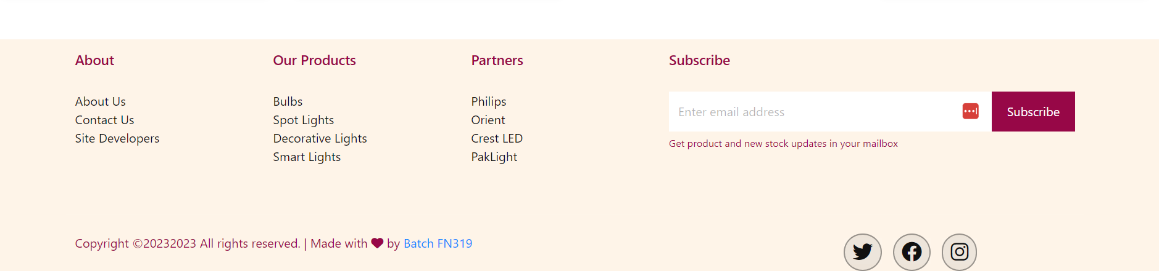

Brand Page:

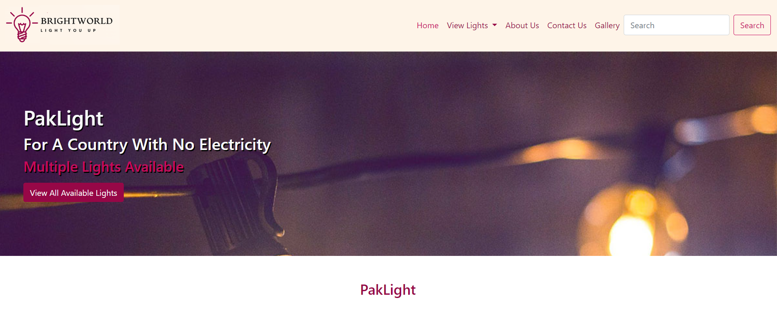

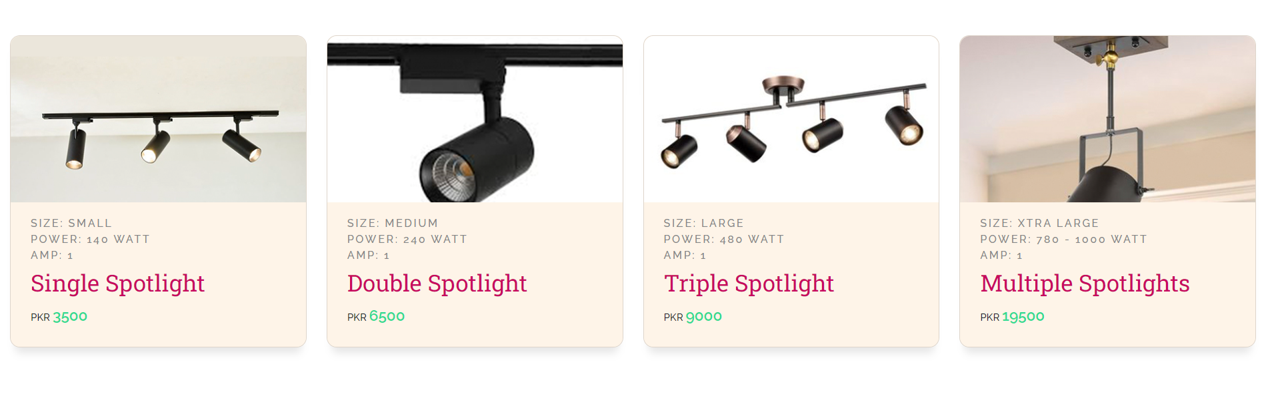

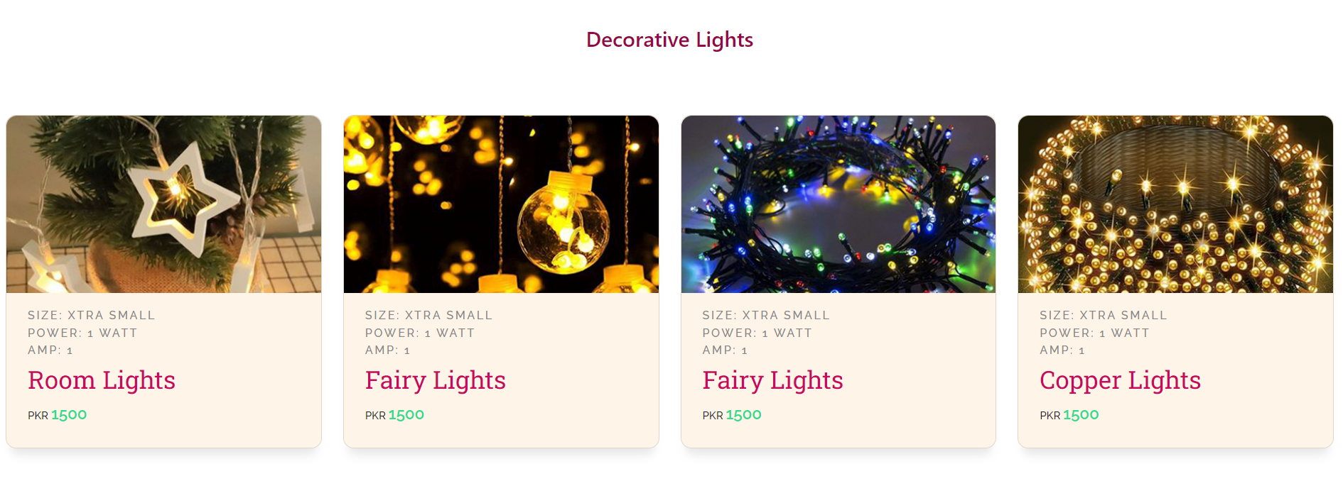

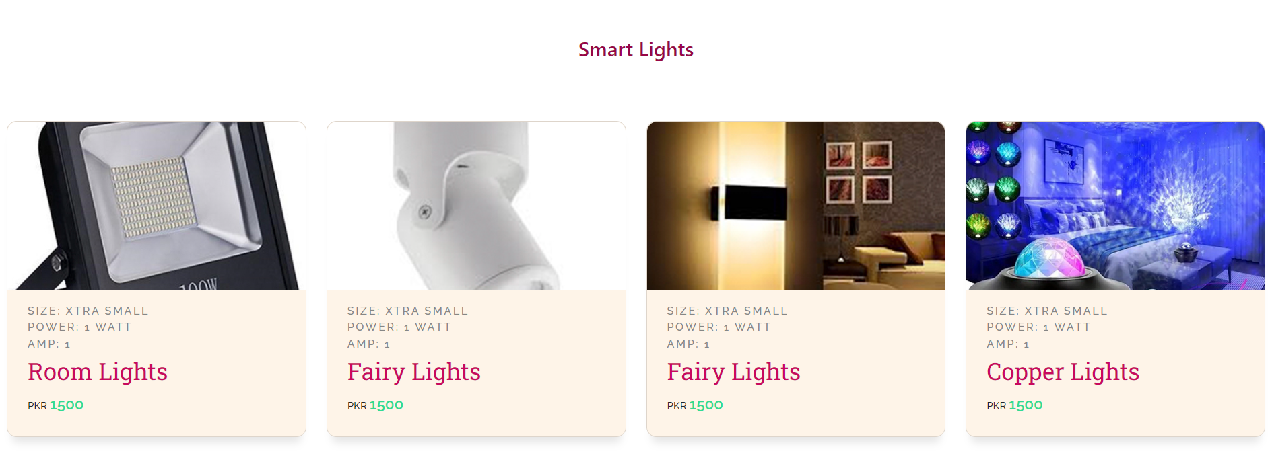

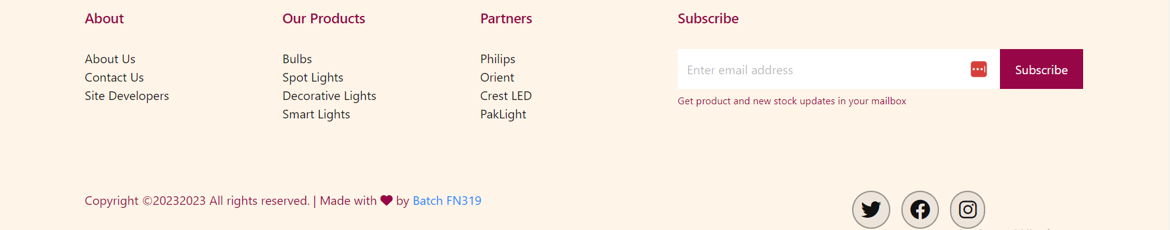

Code Screenshot:

